Certificate
FAQ

Table of Contents
How to install the example QWAC certificate (step-by-step tutorial)……………………………………………..……2
How to add certificate to application………………………………………………………………………………………………….4
How to get OVC SSL certificate for production…………………………………………………………………………….……..7
Certificate FAQ………………………………………………………………………………………………………………………………..….7

1. How to install the example QWAC certificate for test purposes (step-by-step tutorial)
Step 1: Download the QWAC Certificate from the Documentation page.
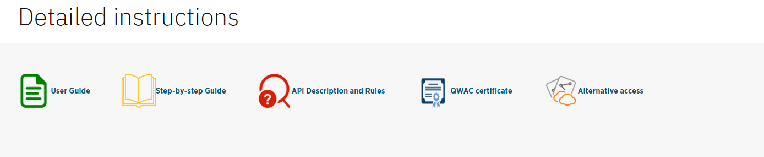
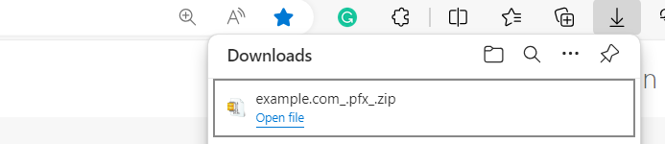
Step 2: Unzip the file in a desired folder.
Step 3: Install the certificate on the browser.
Navigate to the Settings -> Privacy, search, and services -> Security -> Manage certificates.
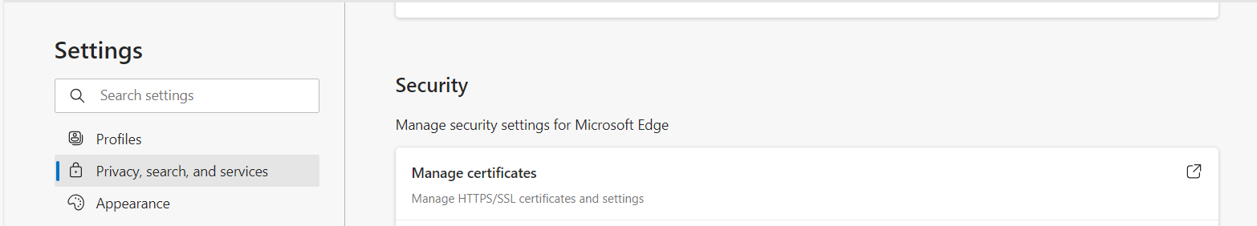
Open the tab and choose import.
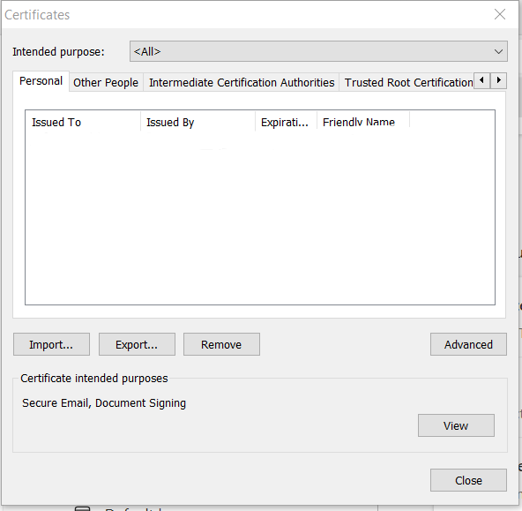
A new window will open with the Certificate import wizard.
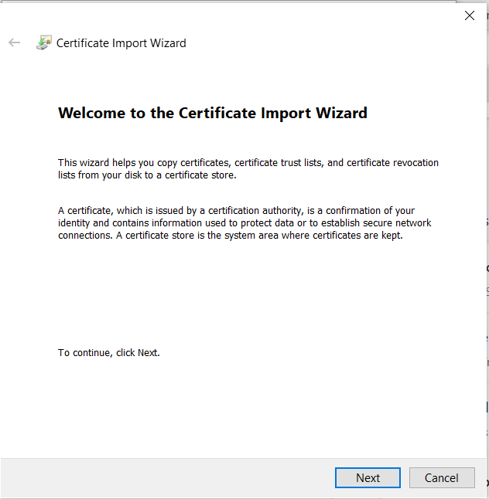
Choose next.
Using the browsing functionality add the unzipped certificate. Click next and insert the 1234 password.
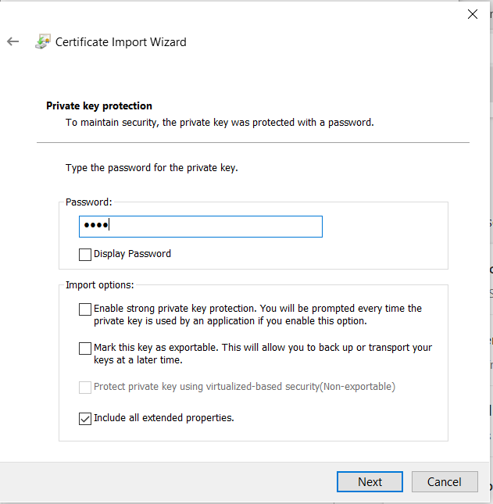
Follow the next steps and the certificate will appear in the Certificate Manage tab:
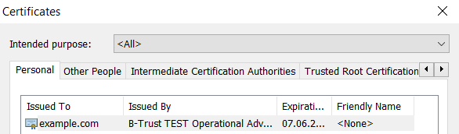

2. How to add certificate to application
Step 1: After the previously described steps are completed from the Certificate manager tab choose the Example certificate and click export.
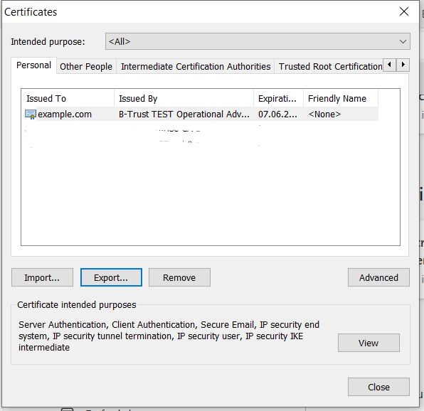
Step 2: The Certificate export window will open, click next. In the next window choose “No, do not export the private key”
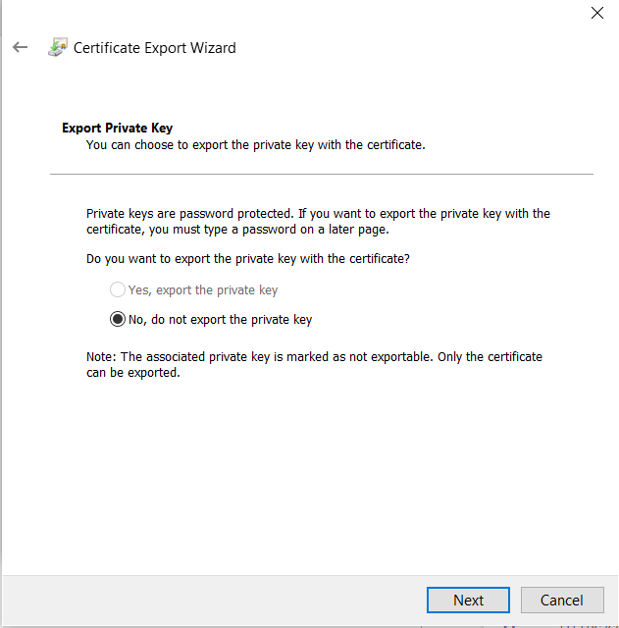
Step 3: In the next window choose Base 64 encoded X.509 (.CER), and click next.
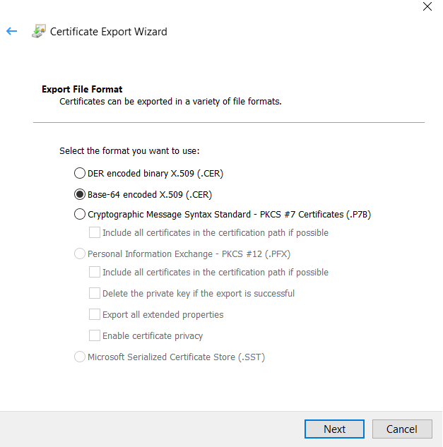
Step 4: Choose a folder where to export the certificate.
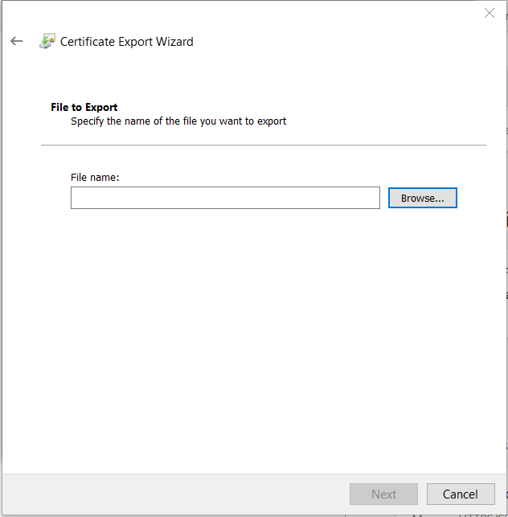
Step 5: After the certificate is exported a completion message will appear.
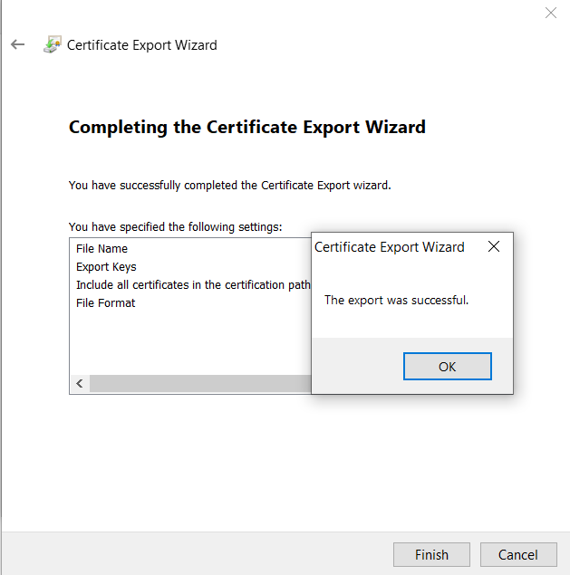
Step 6: After the export is completed navigate to the folder where the certificate is exported and open it with Notepad.
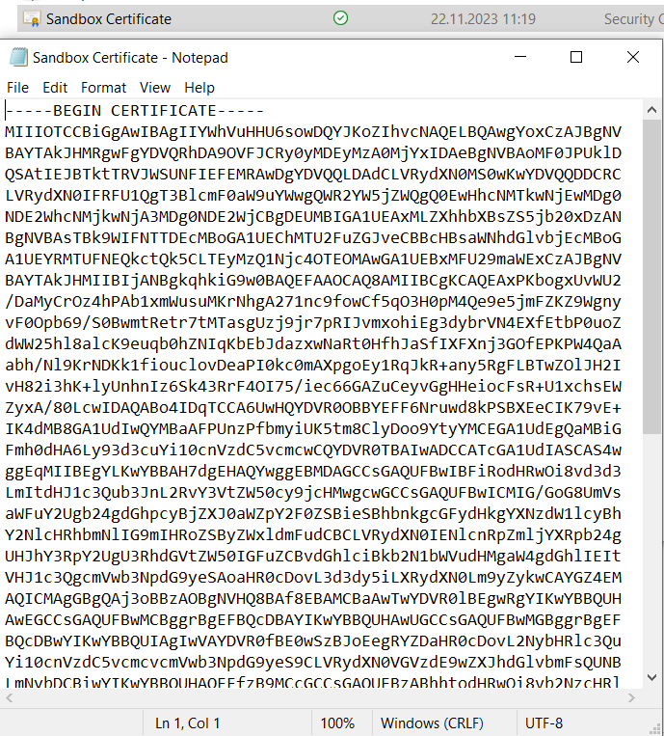
* UBB recommends the certificate to be exported in Windows OS
Step 7: Copy the certificate and insert it in the created application.
Apps | API Developer Portal (ubb.bg) Apps -> Application -> Edit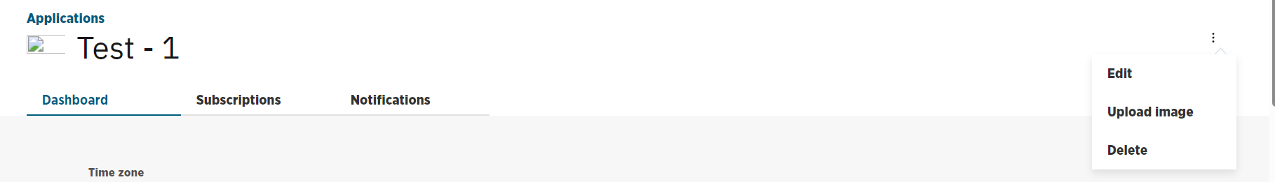

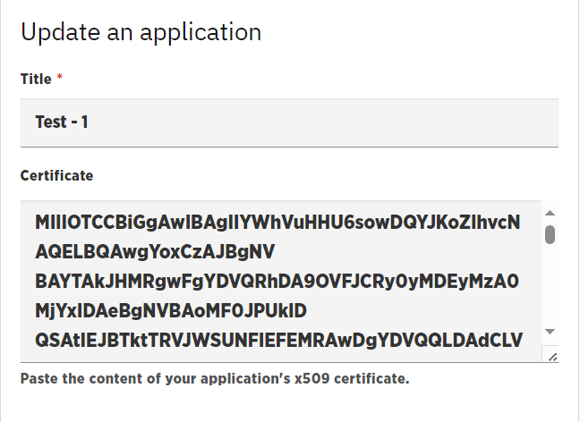

3. How to get OVC SSL certificate for production
Step 1. Ensure that your organization has signed a contract with UBB for the provision of Open Banking Services.
Step 2. An authorized representative from your company should obtain OVC SSL certificate type “Organization” from B-trust.
Step 3. The company`s IT team should install the certificate on the browser and export the public part. Please follow the Step-by-Step guide for examples.
The file (type .cer) must be zipped encrypted and send it to the UBB team on email address ubb_api_integration@ubb.bg. The encryption passphrase must be sent to the same address.
Step 4. After receiving the certificate, the UBB team will register the application. This includes registration, activation, and subscriptions. And send to the company IT team the secrets and URL for API requests in production.
Step 5. The initial requests in production can be started from the company IT team.

4. Certificate FAQ

Who is responsible for the certificate?
- The owner of the company or an authorized representative is responsible for obtaining the certificate for the organization from B-Trust.

Is the certificate secure?
- Yes, the security is based on mutual TLS and OAuth2 together. The certificate is held by the TPPs and UBB. There is a token for real time access to API.

I get an error stating "Application is not registered with mutual tls". What does it mean?
- In this case usually the certificate is not added to the organization in the API developer portal. Check step 6.

Some requests ended with status code 401 and the error message 'This server could not verify that you are authorized to access the URL'. What does it mean?
- Such error appears in case the app loses connection with the certificate. The reasons could be if the certificate is moved or renamed or was not accessible at the moment the request. Another reason can be expiration of access token. Please bear in mind the access token is valid 60 minutes prior to expiration.

The exported public part of the certificate does not look like the example. What is the reason?
- UBB recommends for the export to be done in Windows OS, as other OS does not get the desired format of the certificate.

